MKPPL- BUDESONIDE

The delivery of respiratory medicines via inhalation has become the most popular route in the treatment of asthma. This mode of delivery shows significant promise as a method of treating local infection and as a systemic portal. The use of dry powder inhalers (DPI) has become a popular method of delivering inhalation medicines, since the active pharmaceutical ingredient (API) has greater chemical stability, the dosing options are broader and the passive nature of the device ensures better patient compliance when compared to pressurized and nebulizer-based devices. In order to achieve efficient respiratory deposition, the API should have an aerodynamic diameter <6 μm.
MKPPL SUSPENSION
There is a potential for the development of inhalation medicines in lipid Nanoparticles to possess controlled release properties. MKPPL’s Budesonide suspension has been developed in a complete aqueous base using a couple of specialized solubilizers which also helps in the Nano encapsulation of the drug.
Budesonide Nanoparticles are aimed for the following parameters:
- To enhance the solubility and stability of the drug.
- Concentration scaled up to 5mg/ml in comparison to 0.5 mg/2 ml of the innovator PULMICORT.
- The final concentrated form easily dissolves in inhalable grade water.
DRUG RESULTS
Drug release of the developed Budesonide Lipid Nanoparticle formulation was compared with the innovator (PULMICORT)
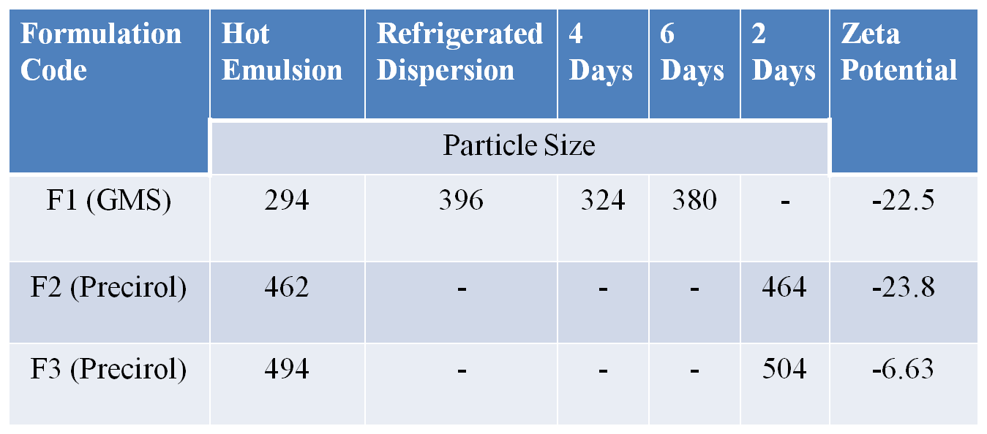
BUDESONIDE DRUG RELEASE
Time | Pulmicort Respules  Innovator (0.25mg) | R&D/BUN/ F2 (0.25mg)
Time | Drug Release in % wt/ml
15 min | 4.9 | 4.3
30 min | 6.0 | 7.8
45 min | 7.8 | 9.4
60 min | 10.1 | 12.5
90 min | 15.0 | 20.3
120 min | 20.3 | 26.2
20 h | 73.5 | 100.2
24 h | 77.8 | 101.9

HIGHLIGHTS OF MKPPL BUDESONIDE NANO SUSPENSION

- MKPPL have entrapped 5 mg of drug in 1 ml of the Nanoparticle formulation, whereas in the innovator formulation 0.25 mg is dispersed in 2 ml.
- Release pattern compared with innovator.
- Controlled release pattern with enhanced solubility is observed in release studies for MKPPL’s Budesonide.
- MKPPL also standardized Bud Clear Suspension (5mg/ml) which is 10 times the concentration of the innovator.
- Particle size of the sample - 300 to 500 nm optimized.
- Zeta potential is - 6 for higher surfactant concentration F3 formulation.
- Stability proves that the Nanoparticles are stable and could be optimized.
- Release rate in preliminary study is in controlled manner and is enhanced compared to the innovator sample.
- The release extends up to 24 hours to reach 100%.

