MKPPL- EVEROLIMUS
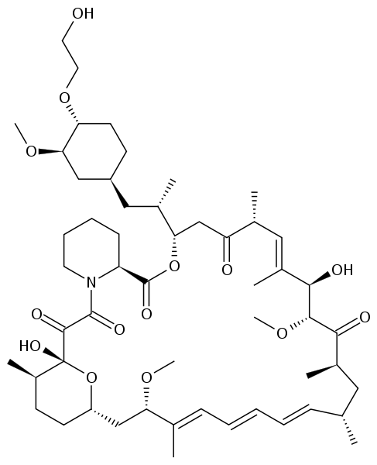
MKPPL is the first to come up with Pellet based approach for Immune Suppressants. Our pellet based approach reduces the variability of absorption of “LIMUS” based immune suppressants owing to smoother and uniform surface of the particles.
The narrow particle size distribution window compared to granules also assures of low dose uniformity. Facilitates direct filling into capsules and can be easily employed in tableting. Nano particles can be effectively used for manufacturing of ointments (Tacrolimus) and solutions (Everolimus). These molecules do not contaminate the manufacturing facility as there is no dusting. Low temperature process operations will minimize the formation of toxic impurities like Delta lactamicos.
ADVANTAGES OF MKPPL EVEROLIMUS
- Prepared using a micro emulsion technology.
- No direct exposure of the pellets with the Fluid Bed Dryer as in granules.
- No cyclization of the drug, hence less delta lactones formation.
- Coated pellets, hence the formulator does not require a contained facility for finished formulation.
- The uniformity generated in pellets helps to give better bioavailability.
MODE OF ACTION
- Certican : Derivative of Rapamycin
  - Works similarly to Rapamycin as an mTOR (mammalian target of Rapamycin) inhibitor
  - Lead to a hyper-activation of the kinase AKT via inhibition on the mTORC1 negative feedback loop while not inhibiting the mTORC2 positive feedback to AKT.
- Prescribed for:
  - Heart transplant reduce chronic allograft vasculopathy.
  - Advance renal cancer.
  - Vascular stent.
MECHANISM
