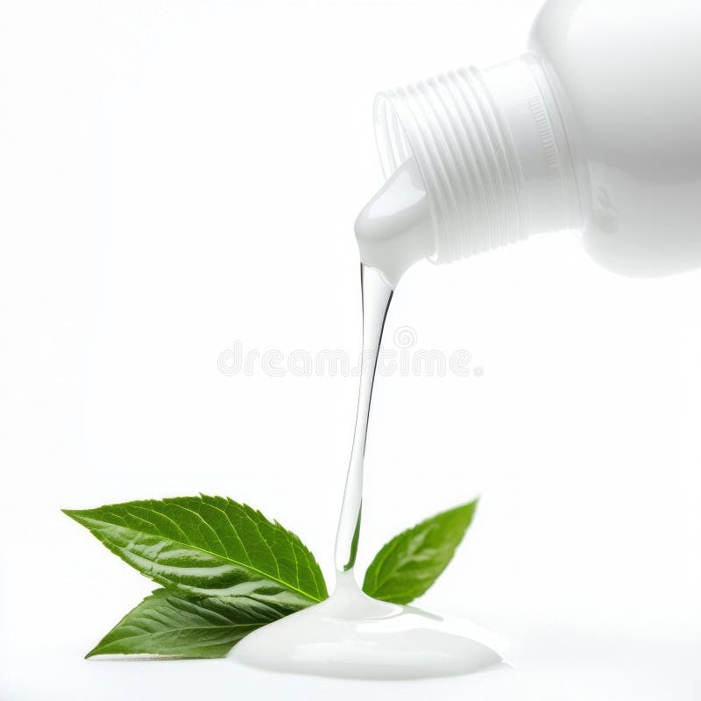
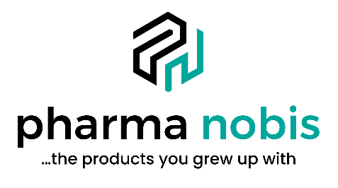

Why Pharma Nobis Is the Liquid CDMO Partner of Choice
Liquid Expertise. Retail Precision. 150+ Years of Trust.
Who We Are
Pharma Nobis is a U.S.-based consumer health manufacturer specializing in OTC and personal care liquids, shampoos, roll-ons, creams, gels, syrups, and solutions.
What Makes Us Different
✔ Liquid Specialists
We are not a “we do everything” plant. We are built for liquids. Period.
✔ OTC Fluent
Monograph-driven. FDA compliant. CCR-controlled label process. Retail-ready documentation.
✔ Retail-Proven
Experience supporting mass, grocery, drug, and Amazon acceleration.
✔ Speed with Structure
Rapid development without regulatory chaos.
✔ U.S. Manufacturing Only
No global complexity. Clean supply chain story.
Ideal Projects
- OTC digestive liquids
- Topical analgesic roll-ons
- Personal care liquids
- Beauty liquids with OTC crossover
- Pet liquids
- Sexual wellness liquids
Not Our Lane
- Solid dose tablets
- Injectables
- Nutraceutical-only blending shops
Broker Advantage
We protect broker relationships. Clear commission structure. No side deals.

