
Editorial Contact:
Yulia Tribrat, Finn Partners (London) | Tel: +44 20 7017 8435 | Email: yulia.tribrat@finnpartners.com
High resolution images available here.
CPC Introduces MicroCNX™ Series Connectors at BioProduction 2021
Only alternative to tube welding for small-volume biopharma processing
St. Paul, Minn. – 02.11.2022 – CPC, maker of AseptiQuik® Series Connectors, will unveil its brand new, ultra-compact MicroCNX™ Series Connectors to the European market at BioProduction 2021 in Milan, Italy, 9-11 November. MicroCNX connectors are the biopharmaceutical industry’s first and much-needed alternative to tube welding for their small-volume closed aseptic processes. MicroCNX connectors will be showcased alongside the AseptiQuik product line in Hall 4 (Booth G64).
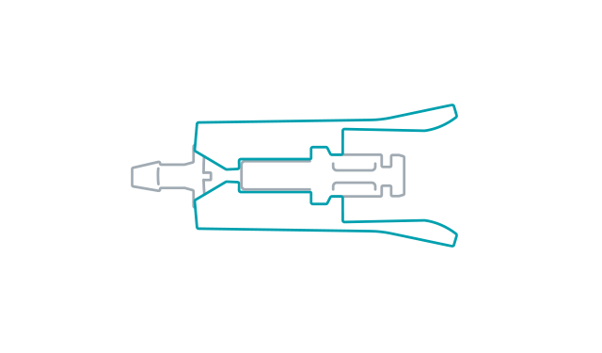
“MicroCNX connectors are a critically important option for a range of bioprocessing, cell therapy and gene therapy workflows,” said Troy Ostreng, senior product manager for CPC’s biopharmaceutical business. “Until now, cumbersome tube welding has been the only way to make sterile closed connections of very small-bore tubing. The MicroCNX connector represents a huge innovation for the industry.”
MicroCNX connectors are designed specifically for small-volume processes involving widely used 1.6mm (1/16”), 2.4mm (3/32”) and 3.2mm (1/8”) tubing. These include sampling, seed train expansion and early cell culture processes involving shaker flasks and rocker tables.
Testing indicates that making a sterile connection with the new connector is up to four times faster than an operator using a tube welder.¹ Multiply those numbers over the course of a year, and the operational efficiencies are clear.
The easy, three-step process for using MicroCNX connectors requires minimal training. Users simply “Pinch-Click-Pull”: 1) pinch to remove the protective cover; 2) click together the connector halves; and 3) pull out the protective membranes so flow can start. In comparison, tube welding involves a dozen or more steps, with operator challenges including maneuvering the tube welder into position, dealing with equipment maintenance, and requiring precise technique to create a successful weld. With MicroCNX solutions, there is no risk of faulty welds, welder breakdowns, or production delays due to weld equipment downtime.
Use of aseptic connectors eliminates the need to purchase, calibrate, validate and maintain tube welders that can cost more than €12,700 ($15,000) each. Manufacturers often need multiple welders, which take up valuable space in a cleanroom.
“MicroCNX connectors can help biopharmaceutical and cell and gene therapy manufacturers make the most of their existing cleanroom space,” Ostreng noted.
MicroCNX connectors can be incorporated into pre-made tubing assemblies, so operators know where to make connections—there’s no guesswork on their part, which supports current good manufacturing practices (cGMP). The size, weight and geometry of the new connector also fit well with the trend toward compact automated equipment for use in processes like cell expansion.
For more information about MicroCNX Series Connectors and how tube welding and aseptic connectors compare, visit endoftheweld.com. To arrange a one-to-one meeting with a CPC expert at BioProduction 2021, please contact Yulia Tribrat at yulia.tribrat@finnpartners.com in advance or drop by booth G64 in Hall 4.
1. Data on file.
# # #
About CPC Biopharma
CPC (Colder Products Company) is a global leader in single-use connection technology, offering a wide variety of connectors for biopharmaceutical manufacturing. Innovative, flexible designs easily combine multiple components and systems including process containers, tubing manifolds, transfer lines, bioreactors and other bioprocess equipment. Robust single-use connectors maintain media sterility and integrity while improving production yields, decreasing time to market and reducing costs. The company’s well-known AseptiQuik® connectors provide quick and easy sterile connections even in non-sterile environments. Learn more about our entire portfolio at cpcworldwide.com/bio. Connect with confidence with CPC, an operating company within Dover Corporation.
CPC, Colder Products, Colder Products Company and Dover are registered trademarks
with the U.S. Patent & Trademark office.

