MKPPL–ITRACONAZOLE
Itraconazole is a 1:1:1:1 racemic mixture of four diastereomers (two enantiomeric pairs), each possessing three chiral centers. SPORANOX® is the innovator for Itraconazole, a synthetic triazole antifungal agent. Itraconazole has a molecular formula of C₃₅H₃₈Cl₂N₈O₄ and a molecular weight of 705.64. It is a white to slightly yellowish powder and is insoluble in water, very slightly soluble in alcohols and freely soluble in dichloromethane. It has a pKa of 3.70 (based on extrapolation of values obtained from methanolic solutions) and a log (n-octanol/water) partition coefficient of 5.66 at pH 8.1.
SPORANOX® Capsules contain 100 mg of Itraconazole coated on sugar spheres. Inactive ingredients are hard gelatin capsule, hypromellose, polyethylene glycol (PEG) 20,000, starch, sucrose, titanium dioxide, FD&C Blue No. 1, FD&C Blue No. 2, D&C Red No. 22 and D&C Red No. 28.
The objective of developing Itraconazole pellets by aqueous technology is to match the dissolution profile of Itraconazole Pellets with SPORANOX without use of organic solvent. Pellets have distinct advantages over single unit system such as multiple unit particles get distributed throughout the GI tract thereby avoiding localized accumulation. Pellets developed by aqueous technology have also advantage of avoiding the use of organic solvents. Itraconazole pellets are developed by Fluid Bed Coating process in which, the suspension of Itraconazole along with other ingredients like hydroxy propyl methyl cellulose, Sodium Lauryl Sulphate and Sodium Starch Glycolate is sprayed on sugar spheres 20 – 24# to get drug loaded pellets. On this pellets Seal coating will be tried using hydroxy propyl methyl cellulose and Polyethylene Glycol-6000. All the ingredients were available from approved vendors for FBC process. All the equipments and Analytical Instruments like HPLC, FTIR, GC, and Dissolution apparatus are available for developed Itraconazole pellets.
DISSOLUTION PROFILE COMPARISON OF ITRACONAZOLE PELLETS OF MURLIKRISHNA PHARMA (MKPPL) & SPORONOX
A comparative study for dissolution was conducted for Itraconazole Pellets 22.0% w/w
B.No. MKPPLR-ITF-14008 of Murli Krishna Pharma and Sporonox Capsules of Janssen.
A weight equivalent to 100 mg of dose was taken from Murli Krishna Pharma (MKPPL)Itraconazole Pellets 22.0% w/w and dissolution study at 5,10, 15,30,45,60 and 90minutes was conducted.
Differential (F1) & Similarity (F2) Factors were estimated from the obtain dissolution data.

DISSOLUTION DATA

TIME (in Min.) | Dissolution (%) of Sporonox  (Batch No.-ODG 651) | Dissolution (%) of MKPPL (Batch No.- MKPPLR-ITF-14008)
5 | 33.84 | 32.7
10 | 57.05 | 56.8
15 | 63.48 | 70.10
30 | 91.84 | 94.3
45 | 93.86 | 99.4
60 | 94.03 | 101.2
90 | 94.58 | 100.3

COMPARATIVE DISSOLUTION PROFILE

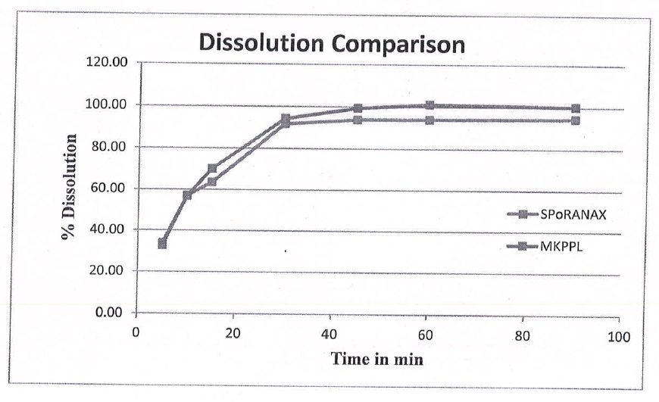

Differential Factor (F1) was found to be 5.47 (0-15 is acceptable)
Similarity Factor (F2) was found to be 65.17 (50-100 is acceptable)

REPORT

From the above values of F1 & F2, It can be concluded that Itraconazole Pellets manufactured at
Murli Krishna Pharma Compare Favorably with that of the marketed product.

